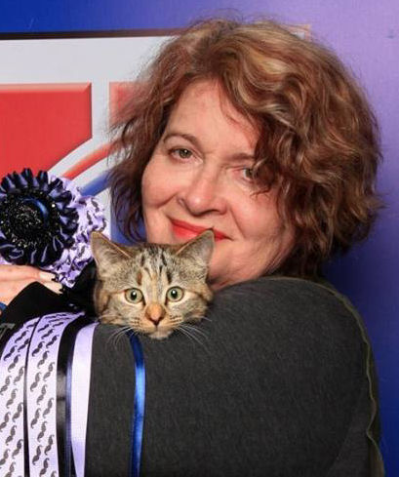 | Karen Pepler  Email Address:karnaki@gmail.com  Website/Portfolio:N/A
CAT JUDGING
Judging Qualifications
Approx Date/s
- Persian/ Exotic/ Chinchilla Longhair 2003
- Siamese/Oriental 1996
- Medium Hair Breeds 2001
- Foreign Breeds 1999

Final Status: Qualified to Judge All Breeds.

International Judging
Kazakhstan(TICA); Australia(CCCA)
CAT FANCY INVOLVEMENT
Club/s
From 1984 to 2016
- Rand Cat Club, Cat Fanciers Club, Transvaal Cat Society, Freestate Cat Club – various positions

Governing Council
- Rand Cat Club Delegate to SACC Governing Council

Judges Council
- Organizer and Presenter of Judges Symposium and Workshop – several times

Cat of the Year
- 2004/2011 Show Manager
- 2014 and 2015 Coty Committee member

Tutor/Judges’ training
1999 onwards – tutor in training new judges
CAT BREEDING
Registered Cattery/Catteries
1985 – Karnaki Cattery

Breed/s
- Previously – Abyssinians, Somalis, Turkish Vans, Scottish Folds, Ragdolls, Skookums, Munchkins, LaPerms, Orientals
- Currently – Birmans, Munchkins

Cat Show History
- Exhibitor from 1984 onwards.
- Breeder of first Somali to attain the title of Supreme Champion, likewise first Ragdoll and first Scottish Fold to win that title.
- Breeder and owner of multiple Supreme Champions and BIS winners.
- Breeder of SACC Cat of the Year 2001
CAT RELATED ARTICLES WRITTEN OR PRESENTED
Title
- Editor of Cat’s Life Magazine
- Multiple articles written for All About Cats, Animaltalk and Cats Life Magazines from 1996 onwards
- Many presentations for judges’ training and at international symposiums abroad.

SKILLS
Languages Spoken – English, Afrikaans
Languages Written – English, Afrikaans

