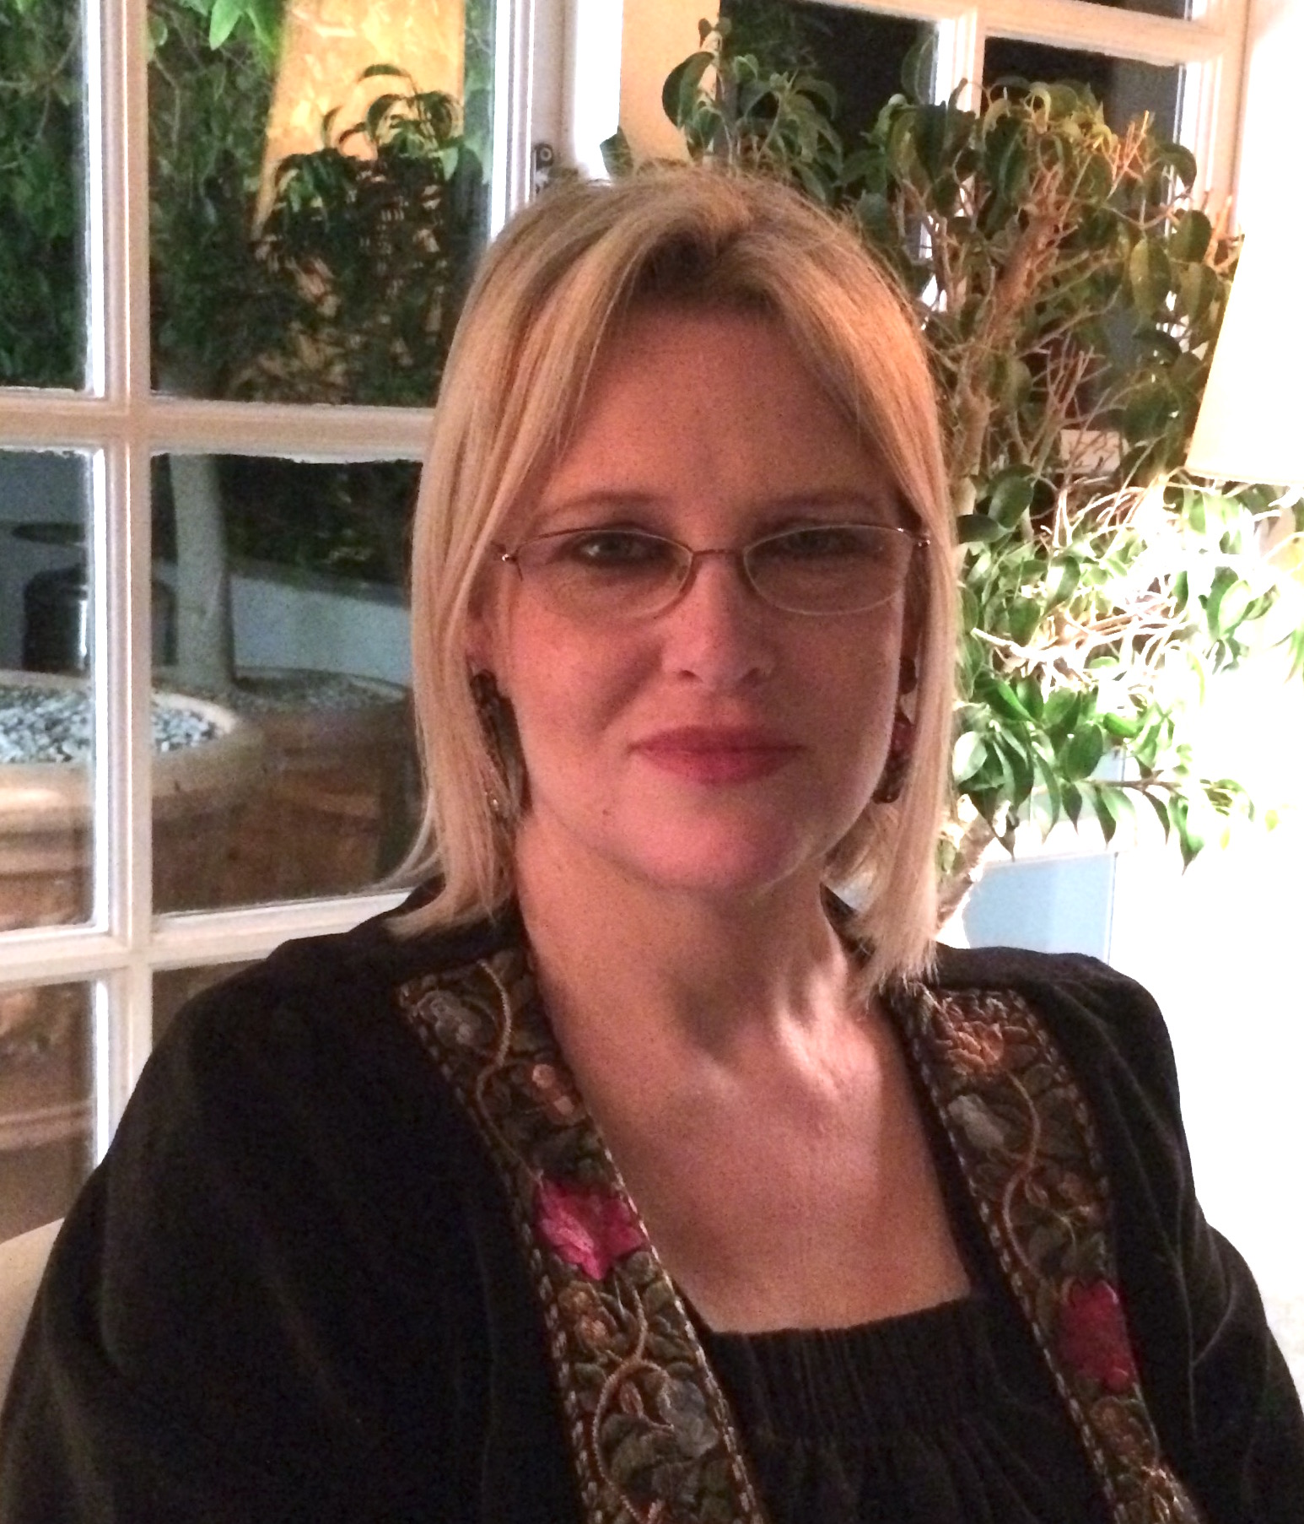 | Ingrid van Eck-Gain  Email Address: ingrid.g@absamail.co.za
CAT JUDGING
Judging Qualifications
2005 - 2018
- Persian/Exotic/Chinchilla Longhair
- Siamese/Oriental
- Medium Hair Breeds
- Foreign Breeds

Final Status: Qualified to Judge All Breeds

International Judging
None as yet
CAT FANCY INVOLVEMENT
Cape Panel of Judges (CPJ)
2005 - current
- Member
2011 - current
- Secretary

Stewarding
2003 - 2018
- Western Province Cat Club
- All Breeds Cat Club
- AICA Independent Shows

Club/s
2005 - current
- Western Province Cat Club Committee
- All Breeds Cat Club Member

Cat of the Year
- 2007 (Rondebosch, Cape Town) Organizing Committee
- 2018 (Observatory, Cape Town) Organizing Committee

CAT BREEDING AND SHOWING

Cat Show History
- Exhibitor for 13 years achieving 3 Supreme Premiers and 2 Cape Top Cat qualifiers.
SKILLS
Languages Spoken – English, Afrikaans, German (conversational),
French (conversational)
Languages Written – English, Afrikaans

