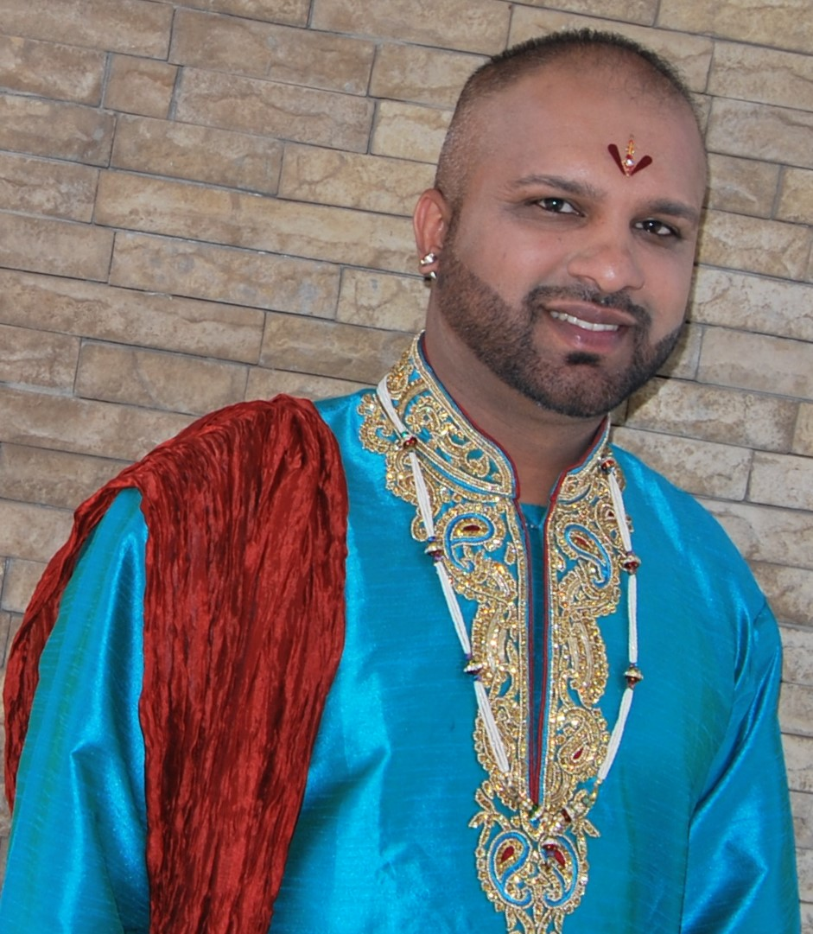 | Lashan Moodley Singh  Email Address:lashanmoodley8@gmail.com  Website/Portfolio:N/A
CAT JUDGING
Judging Qualifications
- Persian/ Exotic/ Chinchilla Longhair - 2017
- Siamese/Oriental - 2013
- Medium Hair Breeds – 2015
- Foreign Breeds as listed – 2021/2022

Final Status: Qualified to Judge Longhairs, Medium hairs and Siamese/Oriental, Burmese, Abyssinian, Somali, British, Russian, Bengal, Cornish Rex, Devon Rex, Selkirk Rex, Peterbald, American Shorthair, Scottish & Highland Folds.

Student
- Remaining SACC Foreign Breeds - 2023

CAT FANCY INVOLVEMENT
Club/s

- Member – PCS, TCS, RCC, BRS and CFC
- Vice Chairperson - Feline Fan Club – 2009 to 2010
- Chairperson – ECKZN Judges Panel – 2015 to present
- Chairperson – Curls and Twirls Breed Group - 2022

Governing Council
- Secretary of SACC – October 2017 to 2021

Judges Council
- Chairperson – 2015 to 2017

Cat of the Year
- Assistant Coordinator – WCC 2019
CAT BREEDING
Registered Cattery/Catteries
C’est L’amour - 2011

Breed/s
- Persian-all patterns and colours (not at present)
- Exotics –all patterns and colours (not at present)
- British – all patterns and colours
- Highland Fold

Cat Show History
- Exhibitor for 10 years achieving 6 Supreme Champions and 4 pedigree and 10 domestic Cat of the Year qualifiers. Owned 3 Cat of the Year Domestic winners.
SKILLS
Languages Spoken – English, Afrikaans
Languages Written – English

