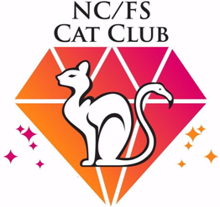 |  |  |  |  | NORTHERN CAPE / FREE STATE CAT CLUB
 |  |  |  |  | All Breeds 3-Ring Championship Cat Show
 |  |  |  |  | 1 June 2024
 |  |  |  |  | Horseshoe Inn, N12 Kimberley
 |  |  |  |  | ENTRY FORM: REGISTERED CLASSES
Please note:
* Enter only one entry (cat) per form.
* Please write clearly in block letters. Illegible and incomplete forms will be returned.
* Incorrect information may lead to disqualification of your entry. Enter only ONE cat per form.
* The information on this form must come from your cat’s official registration form. Incorrect information may lead to disqualification of your exhibit
* It is the responsibility of the exhibitor to ensure that all relevant information is correct – especially concerning the certificates your cat has already been awarded
* All entire male entries of 18 months or older, must have a valid SACC stud Registration Number (stud no).
* Benching will take place from 07:30 Judging will begin at 08:30
* Litter, Litter trays, water bowls & blankets must be provided by the owner.
NB: Please use SACC colour/breed codes!
PLEASE NOTE: CLOSING DATE FOR ENTRIES – 19 May 2024
Name of Exhibitor
Title & Registered Name of Cat:
SACC Registration Number: |  |  |  |  |  |  |  |  |  |  |  |  |  |  | Stud No:
Sex | Male: |  |  |  |  |  | Female: |  |  |  | Neutered Male: |  |  |  |  |  |  | Spayed Female:
Breed: |  |  |  |  |  |  |  |  |  |  |  |  |  |  |  |  |  |  | Breed No:
Colour:
Date of Birth: |  |  |  |  |  |  |  |  |  |  |  |  | Age on Day of Show:
Sire: |  |  |  |  |  |  |  |  |  |  |  |  |  |  |  |  |  | Breed No:
Dam: |  |  |  |  |  |  |  |  |  |  |  |  |  |  |  |  |  | Breed No:
Breeder/s:
Copy of Inoculation certificate enclosed: |  |  |  |  |  |  |  | Yes: |  |  |  | No:

*If the exhibit is not transferred in your name by the closing date, it must be entered as PENDING TRANSFER from previous owner and that person’s name given.
CLASSES ENTERED (Mark only one
3 x Supreme |  | 3 x Grand |  | 3 x Open
1 x Grand and 2 x Supreme |  | 1 x Open and 2 x Grand |  | Kitten 6 – 9 months
2 x Grand and 1 x Supreme |  | 2 x Open and 1 x Grand |  | Kitten 4 – 6 months

CERTIFICATES ALREADY AWARDED
Please – this section MUST be filled in – the onus is on you to supply the correct information
OPEN, GRAND & SUPREME CLASSES
Please give only awards in current class.
CERTIFICATE TYPE | JUDGE | DATE OF SHOW | CERTIFICATE TYPE | JUDGE | DATE OF SHOW

ALL CATS MUST STAY IN THE SHOW HALL UNTIL AFTER THE FINAL JUDGING
Exhibitors may steward their own cats

 |  |  | NORTHERN CAPE / FREE STATE CAT CLUB
 |  |  | All Breeds 3-Ring Championship Cat Show
 |  |  | 1 June 2024
 |  |  | Horseshoe Inn, N12 Kimberley
 |  |  | EXHIBITOR DETAILS & SUMMARY OF FEES
Please complete ALL details on this form.
PLEASE NOTE: CLOSING DATE FOR ENTRIES – 19 May 2024
PLEASE PRINT
Name of Exhibitor: |  | Dr/Mr/Mrs/Miss/Ms
Address:
 |  |  |  |  |  |  |  |  |  |  |  |  | Postal Code:
Tel No: Work: |  |  |  |  |  | Home: |  |  |  |  |  |  |  |  | Cell:
Fax No: |  |  |  |  |  | E-mail:
I am a member of the NC/FS Cat Club |  |  |  | Yes: |  |  |  |  | No: |  |  |  |  | Membership form attached:
SUMMARY OF FEES
Adult cats will be judged in all rings. Kittens will be judged in 3 rings.
FEES |  |  |  |  |  |  |  | MEMBERS |  |  |  | NON-MEMBERS |  |  |  | NO OF ENTRIES |  | AMOUNT
ADULT 1st & 2nd ENTRIES per entry |  |  |  |  |  |  |  | R150 |  |  |  | R170
ADULT 3rd & 4th ENTRIES per entry |  |  |  |  |  |  |  | R 80 |  |  |  | R 90
ADULT 5th & more ENTRIES per entry |  |  |  |  |  |  |  | R 50 |  |  |  | R 50
REGISTERED KITTENS per entry |  |  |  |  |  |  |  | R90 |  |  |  | R120
PETS |  |  |  |  |  |  |  | R 60 |  |  |  | R 80
ITEM |  |  |  |  |  |  |  |  |  |  |  | MEMBERS |  |  |  | NON-MEMBERS
MEMBERSHIP FEES  Ordinary  Family (of 2)  Pensioner |  |  |  |  |  |  |  |  |  |  |  | R 50  R 60  R 40
Please indicate if you are available to steward |  |  |  |  |  |  |  |  |  |  |  | Yes: |  |  |  | No:
The allocations and cage numbers will be available at the door of the show hall.
Catalogues will be emailed
Afterparty: Still to be decided  PLEASE BOOK!! wendywelham@gmail.com |  |  |  |  |  |  |  |  |  |  |  | R |  |  |  | No attend:
 |  |  |  |  |  |  |  |  |  |  |  |  |  |  | TOTAL AMOUNT
NOTE:
* ENTRIES WILL NOT BE ACCEPTED UNLESS ACCOMPANIED BY FULL PAYMENT. No payments will be accepted at the hall.
* Illegible entry forms will be sent back
* Please Note Banking Details: A/c Name: NC/FS Cat Club, Standard Bank: Branch Code: 050002 A/c No: 143815377
* Cats may be withdrawn up to THREE DAYS before the show date - no refunds will be given
* All entries to be E-mailed to: wendywelham@gmail.com OR ncfscatclub@gmail.com
* call Wendy Cell: 083 633 3344

I acknowledge that by participating in this show, I subject myself to the SACC rules and disciplinary
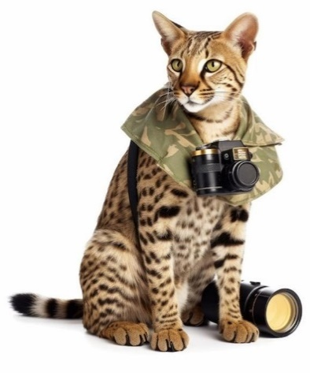
procedures, as mentioned in Paragraph 29 of the SACC Constitution.
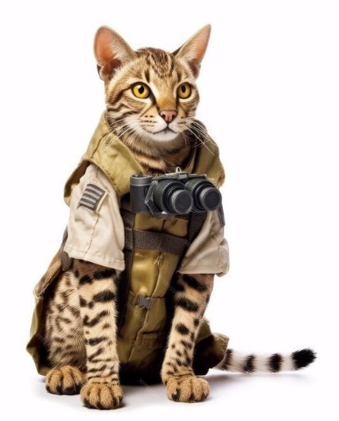
Theme: On Safari

NORTHERN CAPE / FREE STATE CAT CLUB
All Breeds 3-Ring Championship Cat Show
1 June 2024
Horseshoe Inn, N12 Kimberley

SUMMARY OF CATS ENTERED
THIS FORM MUST BE COMPLETED PLEASE
PLEASE NOTE: CLOSING DATE FOR ENTRIES – 19 May 2024

PLEASE PRINT
Name of Exhibitor: |  |  |  |  | Dr/Mr/Mrs/Miss/Ms
Address:
 |  |  |  |  |  |  |  |  |  |  |  |  |  |  |  |  | Postal Code:
Tel No: Work: |  |  |  |  |  |  |  | Home: |  |  |  |  |  |  |  |  |  |  | Cell:
Fax No: |  |  |  |  |  |  |  |  |  |  | E-mail:
Detail to be published in show catalogue (Please tick applicable blocks) PLEASE INCLUDE:
Address: |  |  |  | Home Tel: |  |  | Work Tel: |  |  |  |  |  | Cell: |  |  | Fax: |  |  |  | E-mail:

TITLE & NAME OF CAT | CLASSES | BREED CODE

Fees to be paid directly into the bank account as given on the summary form and the proof of payment attached to entry forms
No entries will be accepted without payment - No late entries will be accepted
NOTE: If you do not receive an acknowledgement of your entry within 24 hours, kindly resend or enquire.

If you have a CFSA or WCF registered cat that you wish to show, it is your responsibility to ensure that it is duly registered with SACC before closing date. You can contact the SACC Registrar for assistance in this regard: email sacatreg@iafrica.com

Theme: On Safari

 |  |  |  | NORTHERN CAPE / FREE STATE CAT CLUB
 |  |  |  | All Breeds 3-Ring Championship Cat Show
 |  |  |  | 1 June 2024
 |  |  |  | Horseshoe Inn, N12 Kimberley
 |  |  |  | ENTRY FORM: DOMESTIC PETS / EXHIBITION CLASSES
Please note:
• Enter only one entry (cat) per form.
• Please write clearly in block letters. Illegible and incomplete forms will be returned.
• Pets over the age of 9 months must be neutered/spayed to enter.
• Please write clearly in block letters – illegible writing leads to mistakes
• Benching will take place from 07:30 Judging will begin at 08:30
• Litter, litter trays, water bowls & blankets must be provided by the owner
NOTE: Note: All pets over the age of nine months must to be neutered / spayed.
PLEASE NOTE: CLOSING DATE FOR ENTRIES – 19 May 2024
PLEASE PRINT
DOMESTIC PET
Name of Exhibitor
Name of Cat:
APPROXIMATE DATE OF BIRTH:
AGE ON DAY OF SHOW:
Sex: | Male Kitten: |  |  |  |  |  |  | Female Kitten: |  |  |  | Neutered Male: |  |  |  |  |  |  | Spayed Female:
Colour / Pattern |  |  |  |  |  |  |  |  |  | Long Hair |  |  |  |  | Medium Hair |  |  |  |  |  |  | Short Hair
Copy of Inoculation certificate enclosed: |  |  |  |  |  |  |  |  |  |  |  |  |  |  |  |  | Yes: |  |  |  |  |  | No:
CLASS ENTERED
Kitten:  4 - 6 Months |  |  |  |  |  |  |  |  | Kitten:  6 - 9 Months |  |  |  |  |  |  | Neutered / Spayed Adult  9 months & older

Fun class: Best Decorated Domestic Cat Cage (All cats entered in the domestic pet section – no extra cost)
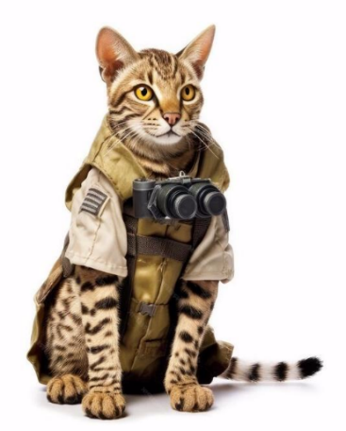

Theme: On Safari

REGISTERED CATS ON EXHIBITION ONLY
Name of Exhibitor
Title & Registered Name of Cat:
Breed & Colour |  |  |  |  |  |  |  |  | Breed No
Date of Birth |  |  |  |  |  |  |  |  | Registration No
Sire: |  |  |  |  |  |  |  |  |  | Breed No:
Dam: |  |  |  |  |  |  |  |  |  | Breed No:
Sex: | Male |  |  |  | Female |  |  | Neutered Male: |  |  |  | Spayed Female:
Copy of Inoculation certifica te enclosed: |  |  |  |  |  |  |  |  |  |  | Yes: |  |  |  | No:
ALL CATS MUST STAY IN THE SHOW HALL UNTIL AFTER THE FINAL JUDGING
Exhibitors may steward their own cats

NEW MEMBER / RENEWAL OF MEMBERSHIP

Name - Mr/Mrs/Ms/Dr………………………………………………………………………………………….

Address…………………………………………………………………………………………………………..

…………………………………………………….…………..…………………………Code…………………

Tel No. (Home)……………………………… …………… (Work)……… ……………………………….....

Cell…………………………………………………. Fax …………………..………………………………….

E-Mail address …………………………………………………………………………………………..……..

Type/s of Cat you Breed/Own .............................................................. …………...............................................

Are you a Registered SACC Breeder? (Please circle) Yes / No
Name of Cattery: ..................................................................................................................................

I, the undersigned hereby make application to join the NC /FS Cat Club and I/we agree to abide by the Club Constitution and Rules and agree to accept as final the decision of the committee in respect of my application.

Signed ………………………………………..……… Date …………………………………
(If under 16 years of age parent/guardian must sign)

Membership Fees:

Full R50.00 p.a
Family (two members) R60.00 p.a.
Junior/Pensioners R40.00 p.a

Payment of R…………………….is attached hereto. Yes ……….. No ……..

Annual fees are due on 1 January of each year.

Banking Details: A/c Name: NC/FS Cat Club, Standard Bank: Branch Code: 050002 A/c No: 143815377
Copy of the deposit slip to accompany this form.

Return to- The Treasurer (Wendy Welham) e-mail: wendywelham@gmail.com OR
Secretary (Carol Kotze) e-mail ncfscatclub@gmail.com
NC/FS Cat Club
22 Zambesi Street
Rhodesdene
Kimberley
8301

PLEASE TAKE NOTE OF THE FOLLOWING IMPORTANT INFORMATION:
A REMINDER OF SACC SHOW RULE (J) REGARDING UNDER AGE KITTENS AT THE SHOWS:
- No kitten under the age of 16 weeks on the day of the show will be allowed in the hall, whether for competition, exhibition or sale.
- No cat/kitten will be allowed inside or outside the show venue or anywhere on the premises on which the show is being held, for any other purpose other than to be judged at the show as an exhibit duly entered for that purpose or officially being entered for exhibition. The sole exception may be cats/ kittens (over the age of sixteen weeks) exhibited / homed / sold by registered Animal welfare organizations. Sale of cats/kittens by any person other than registered Animal Welfare Organizations is strictly prohibited and the Show Manager is entitled to have the person removed.

Kitten classes constitute kittens between the ages of 4 - 9 months (not including 9 months) only. Therefore, no kitten under 4 months (16 weeks) may be entered, whether for competition or exhibition. All exhibits under the age of 3 years, must have a valid inoculation certificate.

RULE 7: FRACTIOUS CATS - If, in the opinion of the Show Manager and the judge concerned, a cat cannot be taken out of its pen, it must not be judged. After 3 disqualifications for fractiousness (3 different shows) or proving unhandleable, an exhibit may no longer be shown

RULE 8.1 (k) : Exhibitors may not choose a specific judge to judge their exhibits, but may exercise the right to request a specific judge not to judge that exhibit and at the show manager's discretion may be allocated another judge.

RULE 11: JUDGE’S DECISION - Save as provided for in rule 10, a judge’s decision shall be final and binding on the exhibitors, save in the case of fraud on the part of the judges or any other person, in which case the decision shall rest with the committee and no correspondence will be entered into.

SHOW RULE 19: The Committee may reserve the right to refuse any entry or entries without giving any reason.

21. DISQUALIFICATION OF CATS
(a) It has been improperly prepared for show, that is, if any dye, colouring lightening or darkening substance, any oils or greasy preparation and cleaning preparations, or any foreign matter of any description has been used and remains in the cat's coat during exhibition; if any of the cat's coat has been cut, clipped, singed or rasped down by any substance; if any of the new or fast coat has been removed by pulling or plucking in any way, or if the eyes have been artificially treated so that the pupils do not show a normal reaction to light;

SHOW RULE 25. DUTIES OF EXHIBITORS: All exhibitors shall ensure that their cats are provided with adequate water for the duration of the Show. Should the exhibitor be unable to be present for the entire duration of the show he/she shall make arrangements to ensure adherence to this rule. It remains, under all circumstances, the responsibility of the exhibitor to ensure compliance to this rule.

SHOW RULE 28 - COMMUNICABLE DISEASES: No exhibitor shall exhibit a cat or kitten which to his or her knowledge has, at the date of the show, been exposed to any specific communicable disease within the period of 30 days prior to the date of the show, and no cat or kitten may be exhibited if the exhibitor has had any such illness in his or her home or cattery during that period. In the case of a communicable disease having occurred in a home or cattery a clearance certificate will be required from a fully qualified veterinary surgeon. Any exhibitor who, in the opinion of the committee, shall have made a false declaration in respect of the above will be liable to serve penalties under the powers of the committee. Owners of rejected exhibits shall not personally attend any show within the prescribed period of 30 days unless in the possession of a veterinary clearance certificate which must be exhibited to the show manager on demand.

RULE 30: FRACTIOUS EXHIBITS - Fractious exhibits shall NOT be considered for nominations for Best in show.

SHOW RULE 18(j): NO SMOKING IS ALLOWED IN HALLS CONTAINING CATS!

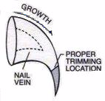

REMEMBER TO CLIP YOUR CATS NAILS!!!!!!

Please be very careful when trimming the nails!

- If your cat changes status after judged, it will automatically be moved to the next Class at no extra cost to the exhibitor, but the onus is on the Exhibitor when completing the entry form to make sure that all awards previously awarded, are correctly listed. i.e. the Certificate awarded and by which Judge. Any errors on the part of the exhibitor cannot be changed on the day of the show so the onus is on the exhibitor to ensure that the correct information is provided at the time of entry.

No cats may wear “jewellery”/collars/“outfits”/”ribbons” etc. (Refer: Performing Animals Protection Amendment Act)

