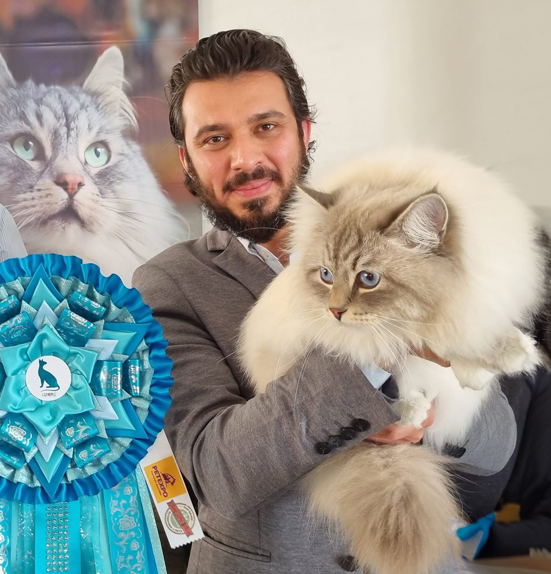 | Ahmed Dockrat  Email Address: adockrat1012@gmail.com  Website/Portfolio: http://ahmed.abrielle.co.za/
CAT JUDGING
Judging Qualifications
• Persian/Exotic/Chinchilla Longhair April 2024

Status: Qualified to Judge Persians, Exotics and Chinchilla Longhairs & Siamese/Oriental.

International Judging: N/A

CAT FANCY INVOLVEMENT
Club/s
2020 - 2021
National Cat Society (CFSA)
- Secretary responsible for communication, minutes and record keeping.
- Marketing & Website Management.

2022 – Present
Breeders of Rex & Sphynx Breed Group
- Marketing & website management.
- Secretary: 2022 - 2023

CAT BREEDING
Registered Cattery/Catteries
I began breeding animals at a young age in India. We primarily bred domestic cats to look after our rice and wheat crops, as well as chasing mice on the farm. In addition to cats, we also bred horses, goats, rabbits, and various types of chickens and ducks.

My involvement in the cat fancy began with my first Siberian imports from Russia in 2019.

Breed/s
- Siberian
  - Blue Tabby Points
  - Red Point
  - Blue Silver Tabby Points
  - Seal Point

Cat Show History
Exhibiting from 2019
Pet Expo overall winner 2023 (SACC, CFSA, CASA)
Gold Cat of the year 2023 (CFSA)
Cat of the year 9th Place 2023 (CFSA)

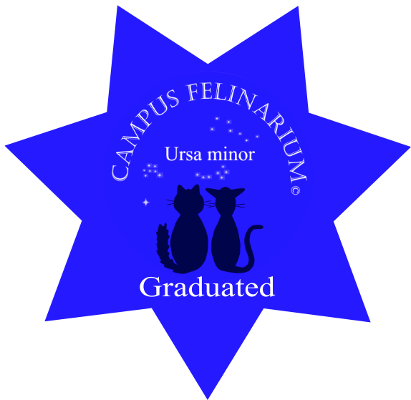
Cat Education

Campus Felinarium
Ursa Minor – 2023



PAW PEDS
G2 Graduates - 2022
G1 Graduates - 2021

Oplex Careers
Cattery Management – 2020

Animal Welfare Victoria
Breeding Dogs and Cats Course - 2020

CAT RELATED ARTICLES WRITTEN OR PRESENTED
Title

Article on nutritional Biologically Appropriate Raw Food (B.A.R.F.) and a recipe created to help cat owners.

For inclusion in club newsletters an article on development of the Siberian cat: their colour and pattern.
SKILLS
Languages Spoken – English, Hindi, Urdu, Gujarati
Languages Written – English, Hindi, Urdu, Gujarati

