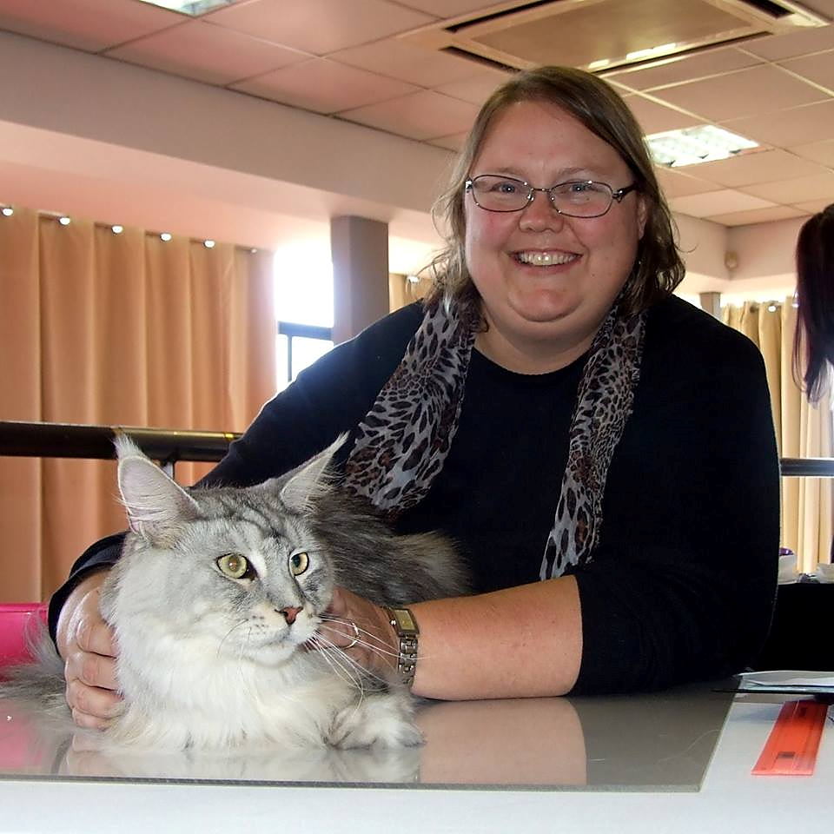 | Natasha Greaves  Email Address:maverickcattery@gmail.com  Website/Portfolio:N/A
CAT JUDGING
Judging Qualifications
Approx Date/s
- Persian/ Exotic/ Chinchilla Longhair - 2018
- Siamese/Oriental - 2012
- Medium Hair Breeds - 2015
- Foreign Breeds – Abyssinian, Somali, British, Burmese, Cornish Rex, Devon Rex and Russian- 2022

Final Status: Specialist judge
International Judging

CAT FANCY INVOLVEMENT
Club/s
Dates
- Cat Fanciers Club - Secretary 1999 – 2002
- Maine Coon Interest Group - Member 1998, secretary 1999 - 2004
- Siamese Oriental Balinese Interest Group – founding member 2017

Judges Council
2016/17
- Member
- Organizer of Judges Symposium and Workshop.

Cat of the Year
- 2002 – 12th Neuter (Maine Coon)
- 2010 – 2nd (Domestic Pet)
- 2011 – 8th Neuter (Maine Coon)
- 2012 – 20th Entire (Oriental)
- 2013 – 15th Neuter (Maine Coon)
- 2014 – 25th Neuter (Siamese)
- 2014 – 26th Neuter (Maine Coon)
- 2017 – 5th Entire (Maine Coon)
- 2018 – 20th Entire (Maine Coon)
CAT BREEDING
Registered Cattery
2001
Maverick Cattery

Breed/s
- Siamese and Orientals 2001 to 2011
- Maine Coons 2005 to present
- Abyssinian and Somali

Cat Show History
- Exhibitor for 21 years. I have a special passion for showing pets and have won numerous Pet of the Day prizes. I have supremed 10 cats.
CAT RELATED ARTICLES WRITTEN OR PRESENTED
Title
Presentation Date

SKILLS
Languages Spoken – English, Afrikaans
Languages Written – English, Afrikaans

